**End-of-Class Exercises: Linear Programming**

**Name: ___________________**

Please work on the following question *individually*.

In the Foreign Currency Trading example, make the following two changes:

* try to make *1 Euro* (instead of 1 dollar in the original question);
* cannot purchase any Brazilian Real.

**Specify Excel and Solver (Only the parts that are different from the class example):**

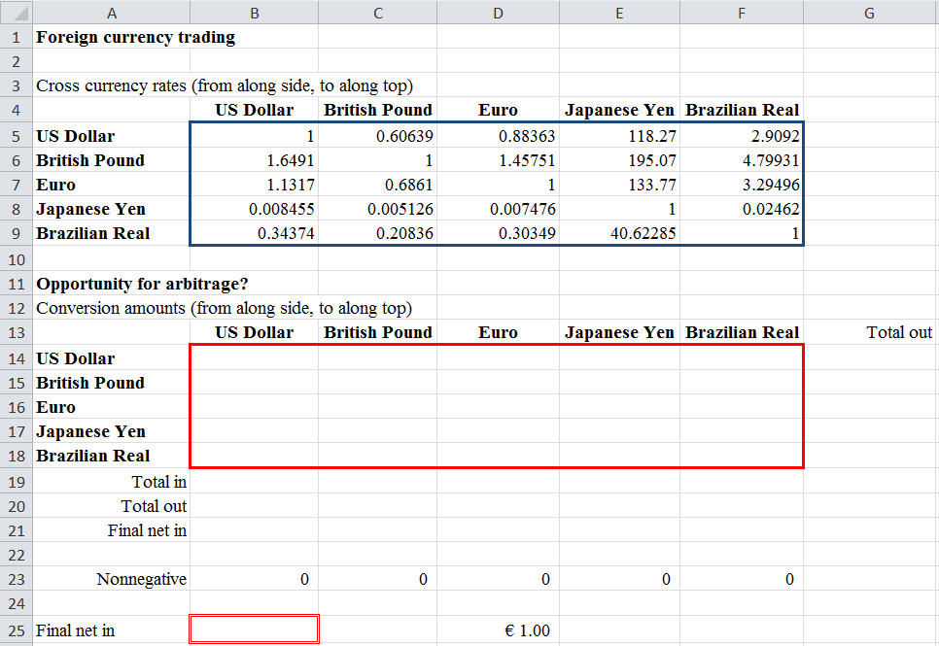

Set Objective: _________

To: ○ Max ○ Min ○ Value of: _________

By Changing Variable Cells: ______________________________________________________

Subject to the Constraints:

|  |
| --- |
|  |

□ Make Unconstrained Variables Non-Negative

Select a Solving Method: Simplex LP

**What’s your recommended currency trading strategy?**

**End-of-Chapter Feedback: Linear Programming**

Pick your favorite question to answer:

1. Provide an example from your own experience where *linear programming* can be used to help you make a decision.
2. Did any example or concept in *linear programming* particularly resonate with you? If so, which one and why?
3. Is any example or concept in *linear programming* confusing to you? If so, which one and why?